ServiceNow Project Documentation

Project Title:
Laptop Request Catalog Item
Team ID: LTVIP2026TMIDS34875
Team Members :
- N V Naga Rohini
- P S Usha Rani
- P Madhu Babu

Faculty Mentor(s) name: Sunitha I

Project Overview:

Problem Statement:
Employees in the organization need a quick and efficient way to request laptops for work. The current process is manual and prone to delays, with no dynamic form behavior to guide users or ensure accurate data collection. To address this, a Service Catalog item needs to be created, allowing users to easily request a laptop, with dynamic fields, clear instructions, and additional functionality like resetting the form if needed. The solution should also ensure all changes are tracked for governance and deployment.
Purpose:
The purpose of this project is to develop a ServiceNow Service Catalog item that enables employees to request laptops in a structured and efficient manner.
The existing manual process was time-consuming and prone to errors. This solution automates the process by:
- Creating a Service Catalog item
- Adding dynamic fields using UI Policies
- Implementing client-side UI Actions
- Managing deployment using Update Sets
This ensures governance, maintainability, and structured data collection.

Goals
- Automate laptop request process
- Collect structured employee data
- Implement dynamic form behavior
- Ensure mandatory validation
- Enable form reset functionality
- Track and migrate changes using Update Sets

Key Features
- Laptop Request Catalog Item
- Dynamic field visibility using Catalog UI Policy
- Mandatory Accessories Details when checkbox selected
- Reset Form button using UI Action
- Update Set Export & Import
- Testing in target instance

- Prerequisites
Software Requirements
- ServiceNow Personal Developer Instance (PDI)
- Web Browser (Chrome/Edge)
- GitHub Account
- SmartInternz Platform

Prior Knowledge Required
- ServiceNow Basics
- Service Catalog
- UI Policies
- UI Actions
- Update Sets
- Client-side scripting

- Project Flow
- Create Local Update Set
- Create Service Catalog Item
- Add Variables
- Create Catalog UI Policy
- Create UI Action
- Export Update Set
- Import into Target Instance
- Testing

- Activities Overview
🔹 Step 1: Create Update Set
- Created Local Update Set named Laptop Request
- Set State to In Progress
- Made it Current
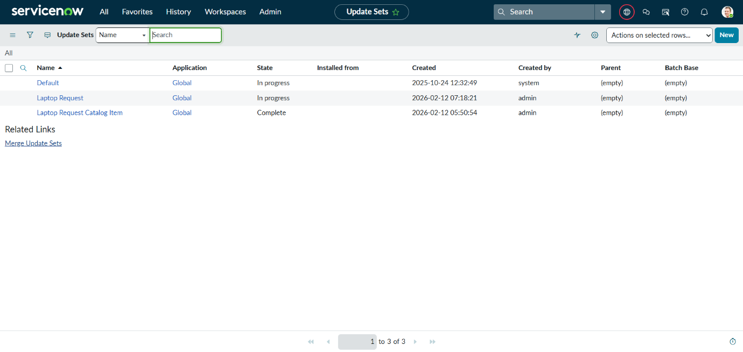
FIG: Update Set Creation

🔹 Step 2: Create Service Catalog Item
- Name: Laptop Request
- Catalog: Service Catalog
- Category: Hardware
- Short Description: Use this item to request a new laptop
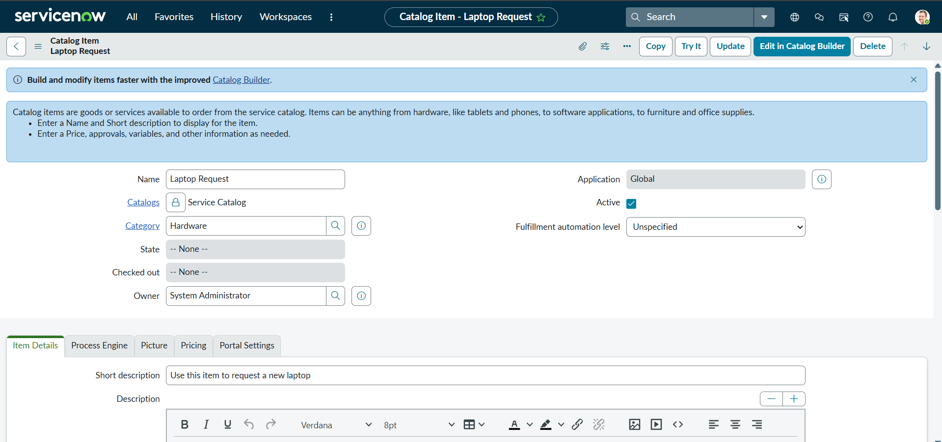
FIG: Service Catalog Item Creation

🔹 Step 3: Add Variables

Variable | Type | Name | Order
Laptop Model | Single Line Text | laptop_model | 100
Justification | Multi Line Text | justification | 200
Additional Accessories | Checkbox | additional_accessories | 300
Accessories Details | Multi Line Text | accessories_details | 400

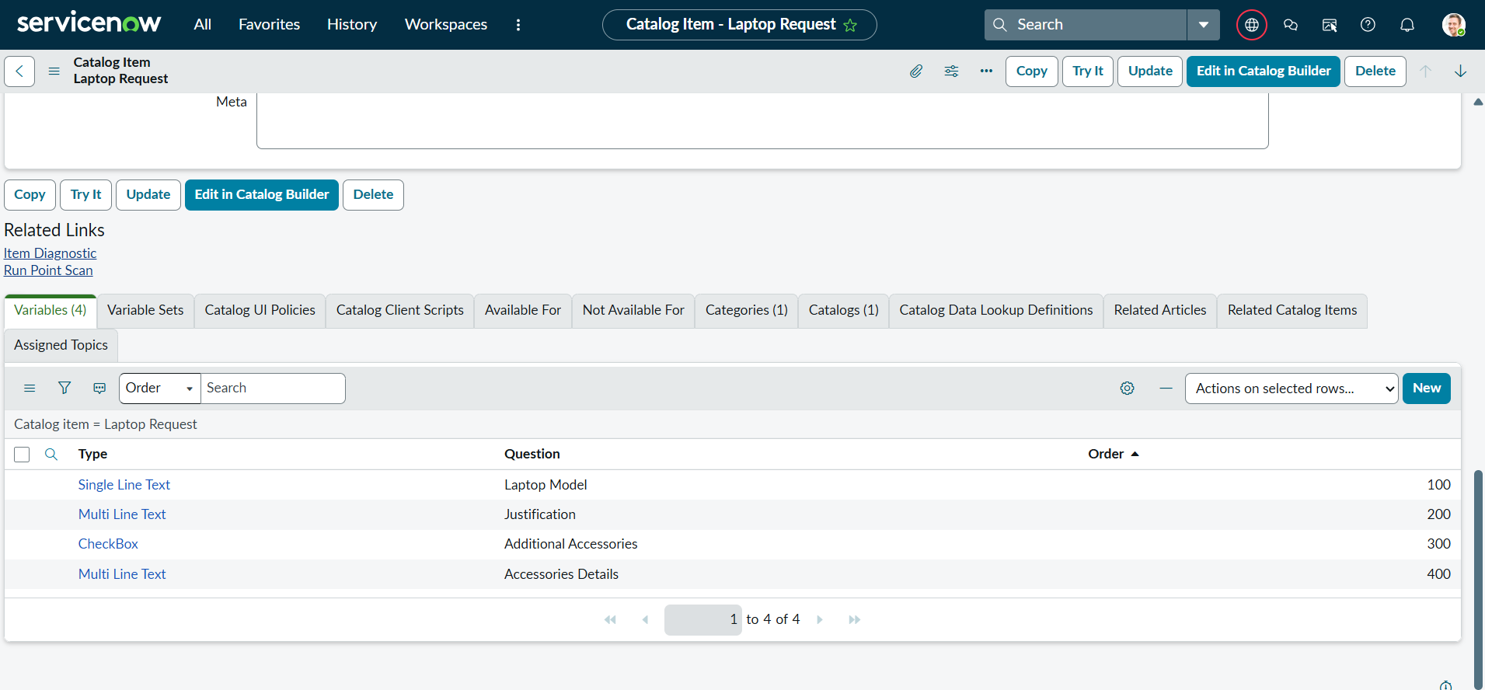
FIG: Variables List

🔹 Step 4: Create Catalog UI Policy
Condition:
additional_accessories is true
Action:
- Variable: accessories_details
- Mandatory: True
- Visible: True
- Reverse if false: Checked
- On load: Checked

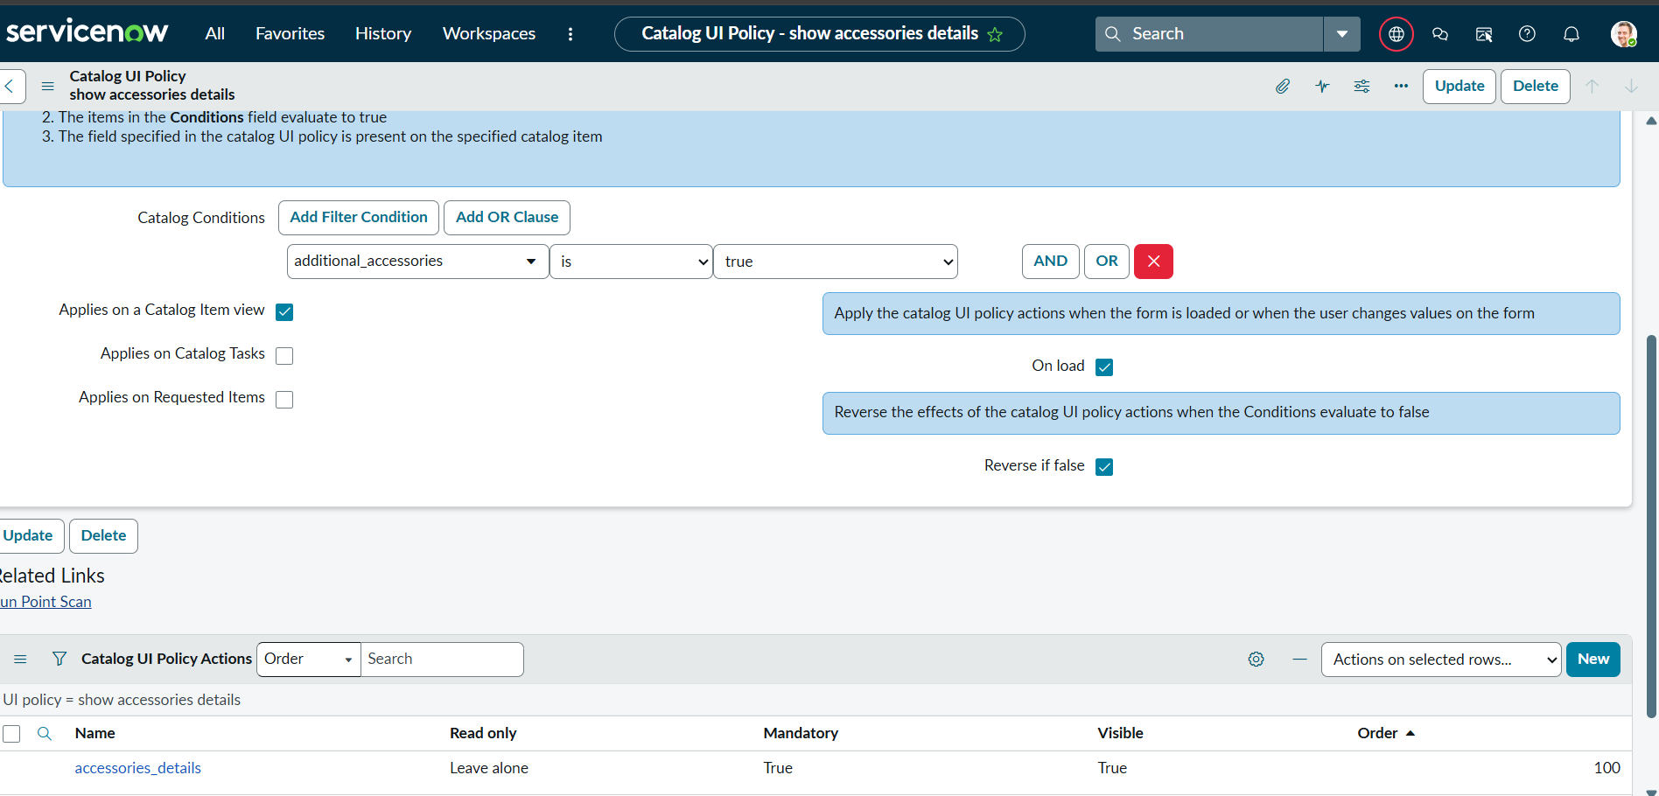
FIG: Catalog UI Policy

🔹 Step 5: Create UI Action
- Table: Shopping Cart (sc_cart)
- Name: Reset Form
- Client: Checked
- Form Button: Checked
Script:
function resetForm(){
g_form.clearForm();
alert("The form has been reset.");
}
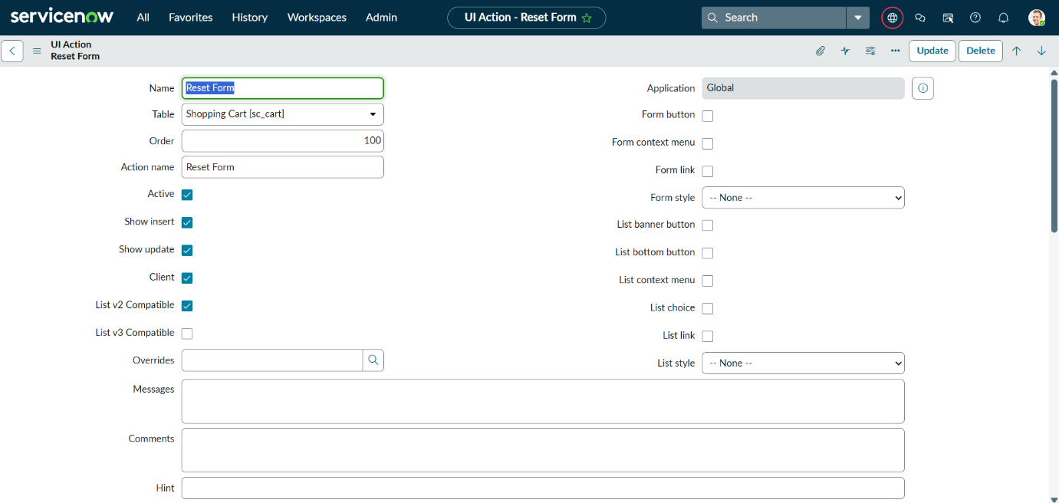
FIG: UI Action Reset Form

🔹 Step 6: Export Update Set
- Set Update Set state to Complete
- Exported as XML

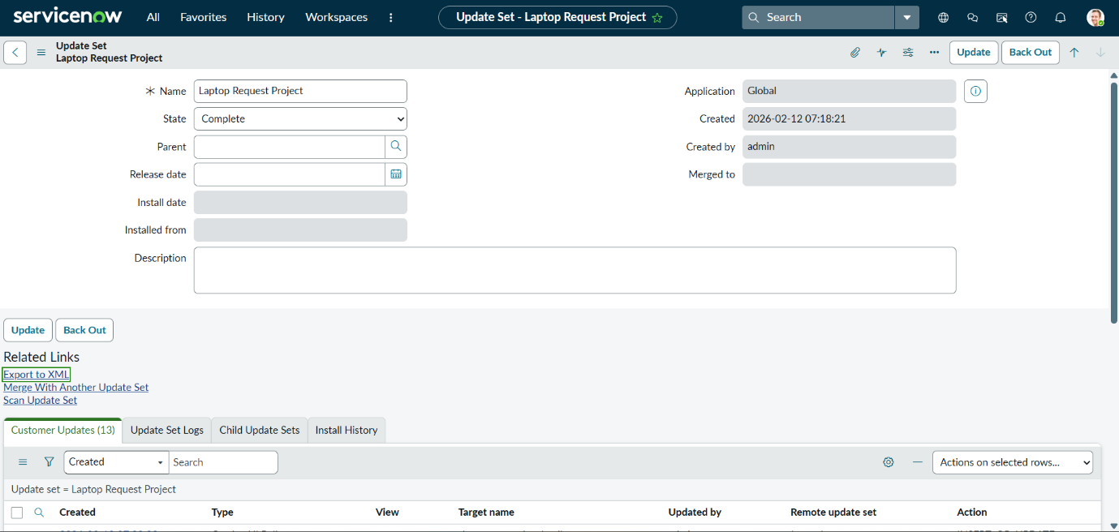
FIG: Export Update Set

🔹 Step 7: Retrieve & Commit Update Set in Target Instance
- Imported XML into target instance
- Previewed Update Set
- Committed Update Set
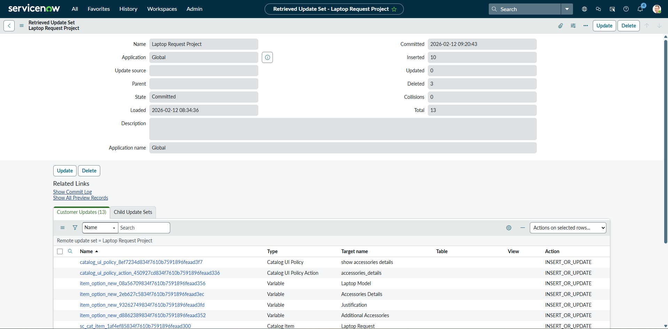
FIG: Retrieved Update Set and Commit Process in Target Instance

🔹 Step 8: Testing
- Opened Service Catalog
- Selected Hardware → Laptop Request
- Verified:
✔ Accessories Details hidden by default
✔ Becomes visible when checkbox selected
✔ Field becomes mandatory
✔ Reset button clears form
The functionality meets all SmartInternz project requirements.

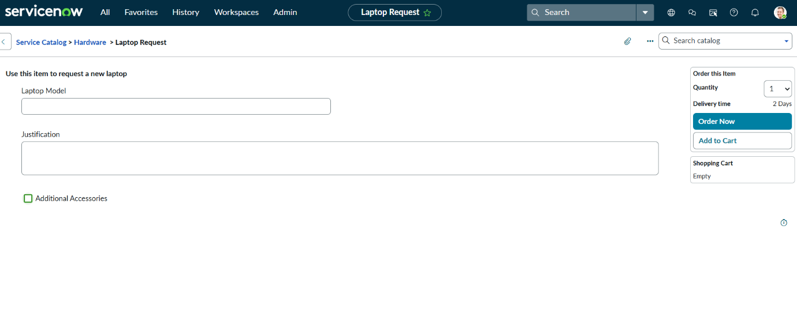

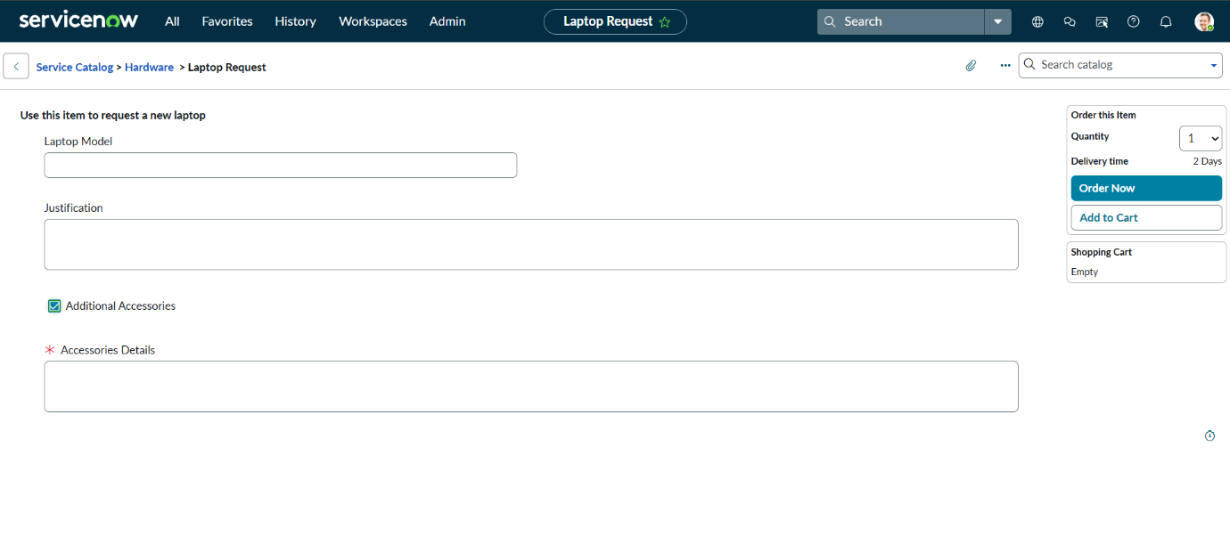
FIG: Testing (Before and After Checkbox)

- Results
The following SmartInternz requirements were successfully completed:
• Update Set Creation
• Service Catalog Item Creation
• Variable Configuration
• UI Policy Implementation
• UI Action Creation
• Update Set Export & Import
• Functional Testing

- Conclusion
The Laptop Request Catalog Item project successfully streamlines the process of requesting laptops within the organization by leveraging ServiceNow's Service Catalog capabilities. Through the implementation of a dynamic catalog item, the project ensures that users have an intuitive and user-friendly interface, reducing errors and improving efficiency. This project demonstrates how ServiceNow can be used to replace manual, error-prone processes with automated, efficient, and user-centric solutions. It not only improves service delivery but also enhances employee satisfaction by providing a modern and streamlined request experience.

- Future Enhancements
- Add Approval Workflow
- Integrate with Asset Management
- Add Email Notifications
- Role-based access control

- Appendix
- GitHub Repository Link:
https://github.com/NelabhotlaVenkataNagaRohini/Laptop-Request-Catalog-Item-ServiceNow
- Demo Video Link: https://drive.google.com/file/d/11IVpQHp9Sj2Zljf95VWNIQSmclemv7lJ/view?usp=sharing
- Update Set XML File: Laptop_Request_Project.xml

